Hive Installation Guidelines

**1.Prerequisite:** Hadoop 3.2.4

**2. Download and Configure Apache Derby:**

a) Download Derby 10.14.2.0 (It's Compatible to Hadoop 3.2.4 ) from https://db.apache.org/derby/derby_downloads.html

b) Extract the file using WinRar, 7Zip, or similar software.

c) Copy the extracted folder to `C:\` and rename it to `derby` (e.g., `C:\derby`).

**3. Download and Configure Apache Hive Binaries:**

a) Download Hive 3.1.2 (It's Compatible to Hadoop 3.2.4 ) from https://archive.apache.org/dist/hive/hive-3.1.2/

b) Extract the file using WinRar, 7Zip, or similar software.

c) Copy the extracted folder to `C:\` and rename it to `hive` (e.g., `C:\hive`).

d) Navigate to `C:\derby\lib` and copy all the `*.jar` files.

e) Paste the copied `*.jar` files into `C:\hive\lib`.

f) Download the exact `hive-site.xml` file from my Google Drive.

g) Copy the downloaded `hive-site.xml` file and paste it to `C:\hive\conf` folder.

**4. Cross Check guava-x.y-jre file:**

a) Make sure C:\hive\lib must have same version of guava-x.y-jar file as Hadoop version: C:\hadoop\share\hadoop\common\lib

For example: C:\hadoop\share\hadoop\common\lib\guava-27.0-jre.jar

Then C:\hive\lib\guava-27.0-jre.jar

b) If not just copy the Hadoop verison guava-27.0-jre.jar and paste into C:\hive\lib and delete the other version guava-x.y-jre.jar file

**5. Create a temporary folder named 'tmp'**into C:\hive (e.g, C:\hive\tmp) and provide all rights by setting the properties of folder

**6. Set Up Environmental Variables:**

- `DERBY_HOME` : `C:\derby`

- `HIVE_HOME` : `C:\hive`

- `HIVE_BIN` : `C:\hive\bin`

- `HIVE_LIB` : `C:\hive\lib`

- `HADOOP_USER_CLASSPATH_FIRST`: `true`

**7. Download and Configure Wget:**

a) Download wget zip files from https://eternallybored.org/misc/wget/

b) Extract the wget zip files.

c) Copy the extracted folder to `C:\` and rename it to `wget` (e.g., `C:\wget`).

d) Set the 'path' for wget in Environmental Variables: `C:\wget`.

**8. Download Windows Version of Hive Bin:**

a) Navigate to a specific directory and create a folder of your choice (e.g., `C:\bin`).

b) Open Windows Command Prompt and run:

wget -r -np -nH --cut-dirs=3 -R index.html

https://svn.apache.org/repos/asf/hive/trunk/bin/

c) Navigate to `C:\bin` and its subdirectories until you reach the `bin` folder.

d) Copy the inner `bin` folder.

e) Navigate to `C:\hive`, delete the existing `bin` folder, and replace it with the downloaded `bin` folder.

**9. Run the Hadoop deamons:**

a) Command to run deamons: start-all.cmd

b) Commands to check deamons running: jps

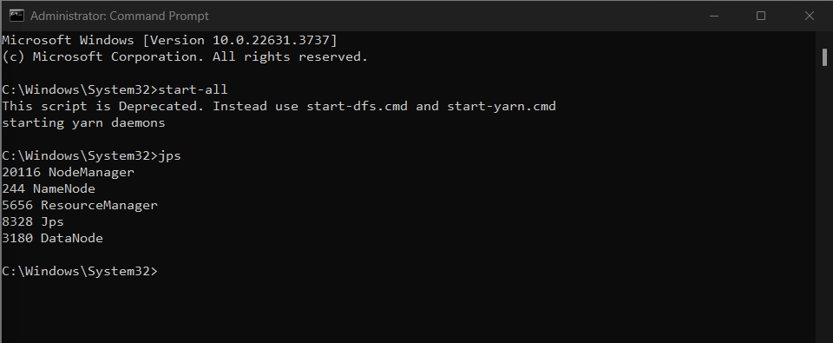

**10. Run Derby Server**

a) Command: `StartNetworkServer -h 0.0.0.0`

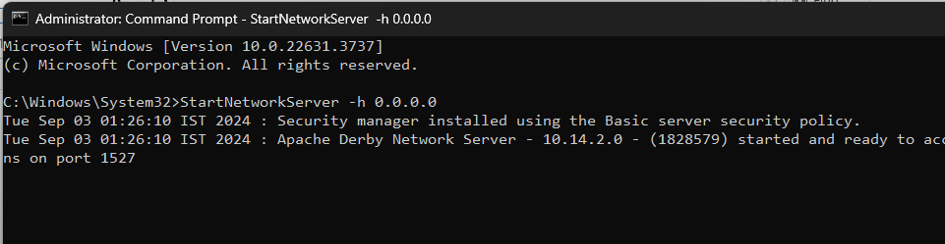

**11. To Initialize Hive Schema:**

a) Navigate to `C:\hive\bin` and run below command: hive --service schematool -dbType derby –initSchema

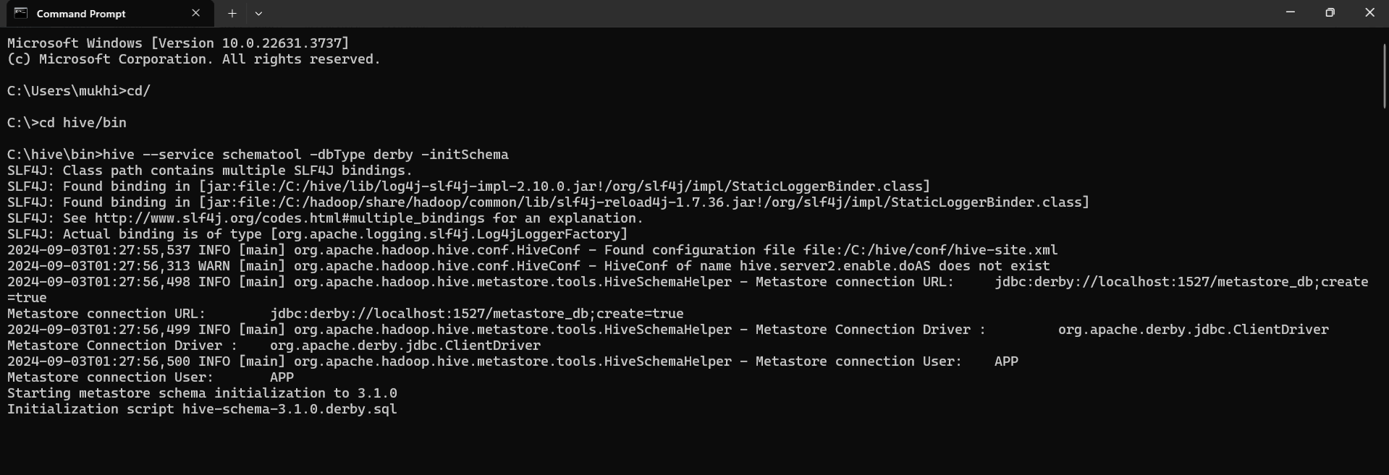

**12. Start Hive:**

a) Command: `hive`

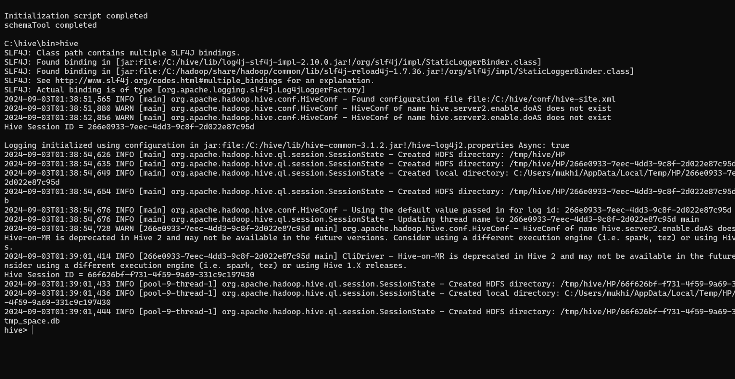

13: Create a Hive Database :

CREATE DATABASE IF NOT EXISTS mydatabase;

USE mydatabase;

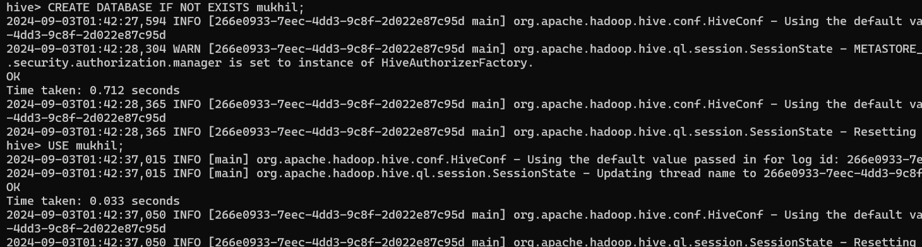

14. Create a Table:

CREATE TABLE employees ( id INT, name STRING, age INT, department STRING ) ROW FORMAT DELIMITED FIELDS TERMINATED BY ',' STORED AS TEXTFILE;

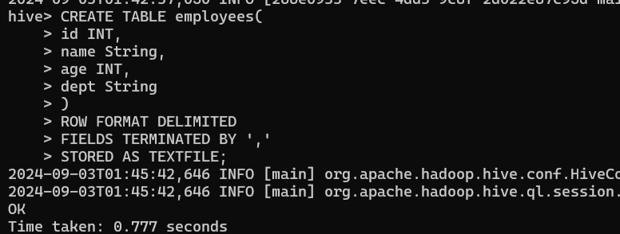

15. Load Data into the Table  
 employees.txt   
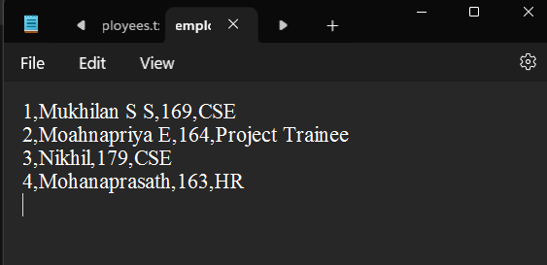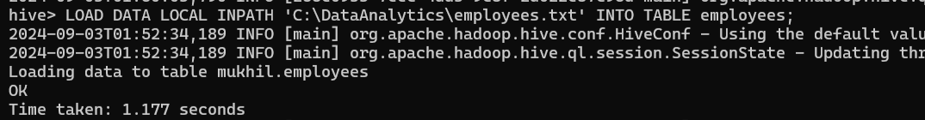

16. Query the Data:

SELECT * FROM employees; 